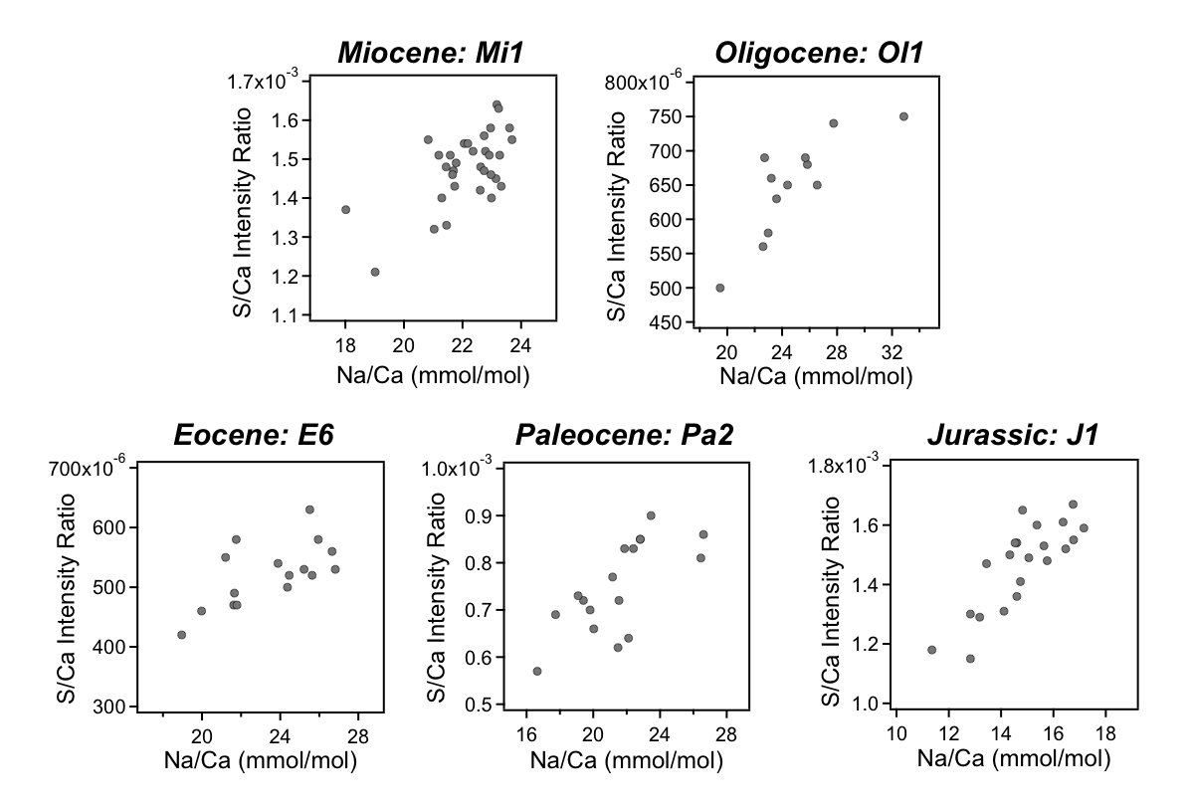

**Electronic Annex-14.** Plots of S/Ca (Intensity Ratio) vs. Na/Ca (mmol/mol) in 5 individual samples of representative ages. We observe a positive relationship between S/Ca and Na/Ca in most samples, but not all.