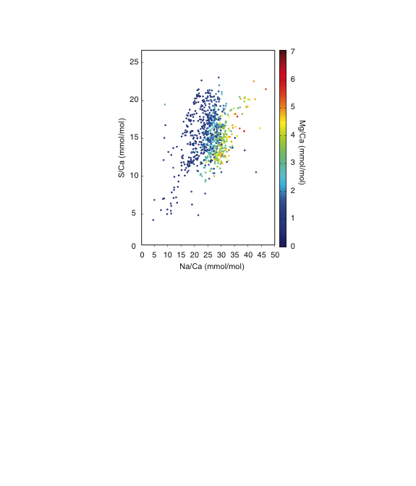

**Electronic Annex-15.** S/Ca vs. Na/Ca as in Fig. 7 of the main text, but SIMS analyses are colored according to their Mg/Ca ratios. Although Mg/Ca ratios measured in older specimens are generally lower, there appears to be no significant trends between S/Ca, Na/Ca, and Mg/Ca for corals of the same general geologic age.