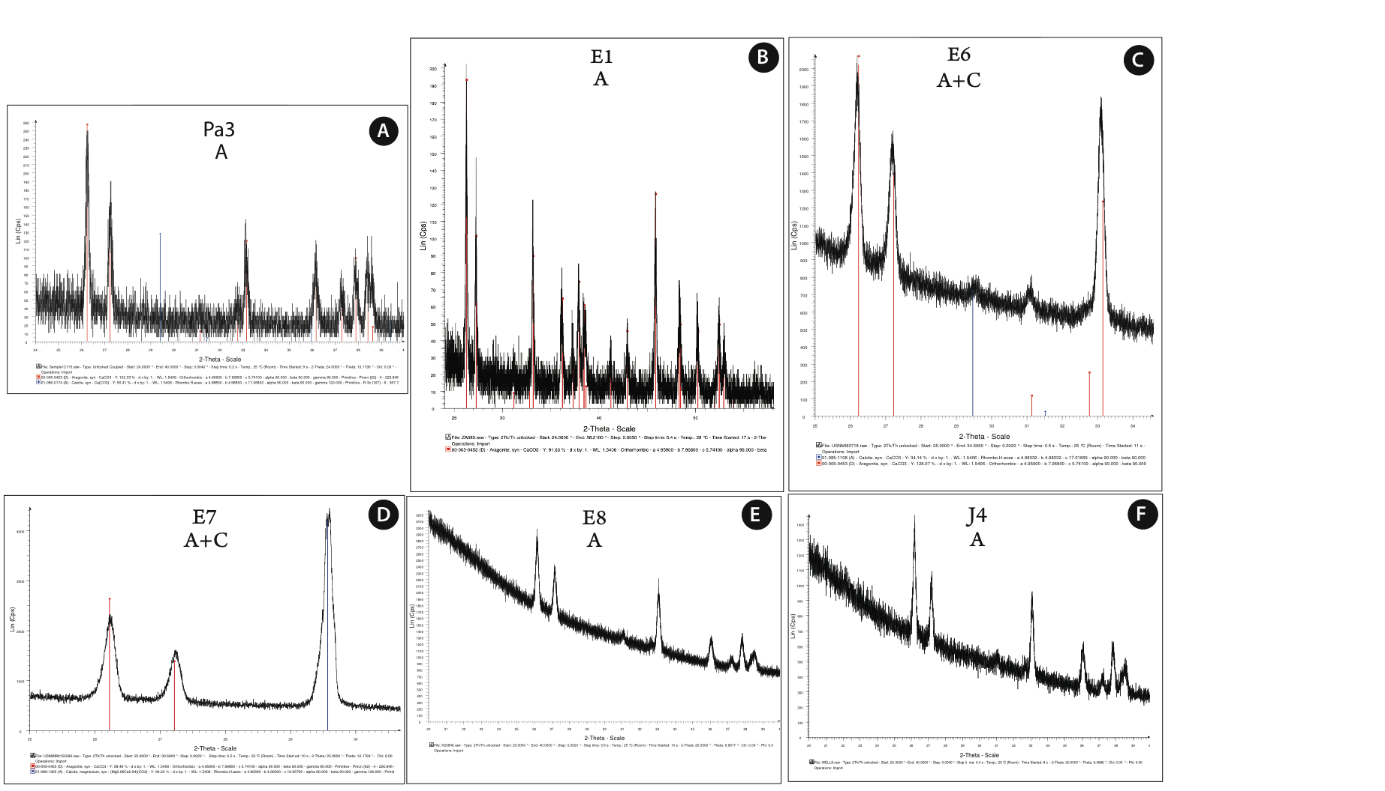

**Figure EA4a.** Representative XRD patterns for 1 Paleocene (A), 4 Eocene (B-E), and 1 Jurassic (F) specimen.

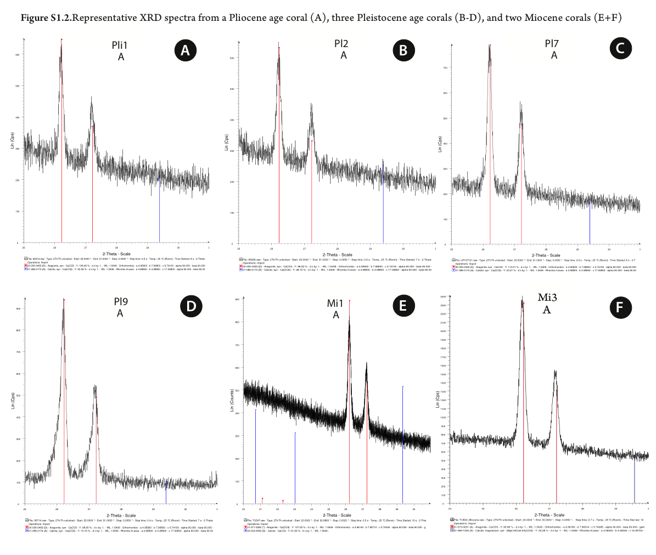

**Figure EA4b.** Representative XRD patterns for 1 Pliocene (A), 3 Pleistocene (B-D), and 2 Miocene (E, F) specimens.

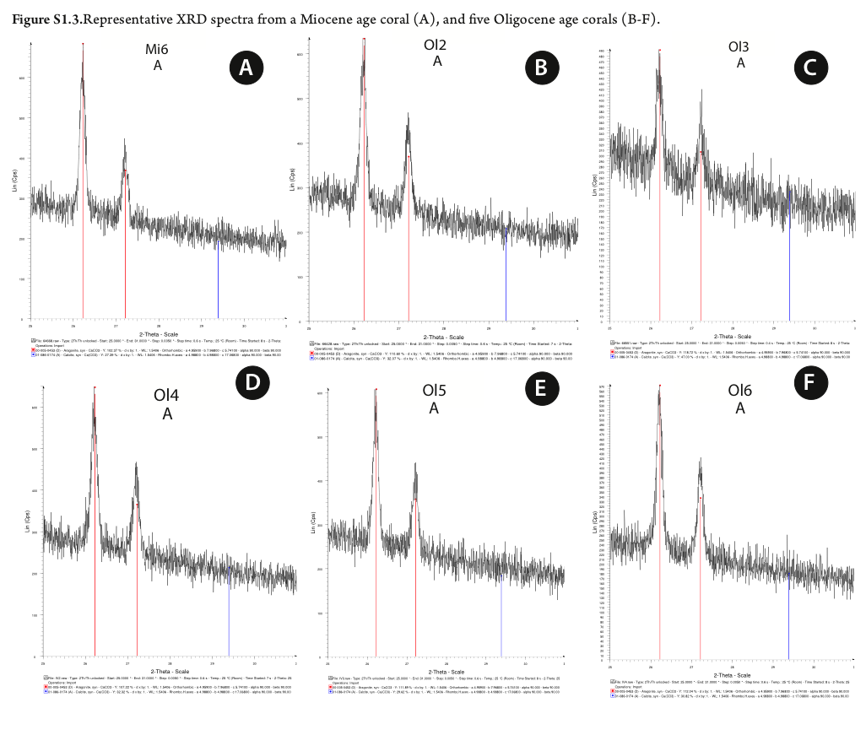

**Figure EA4c.** Representative XRD patterns for 1 Miocene (A), 5 Eocene (B-F) specimens.

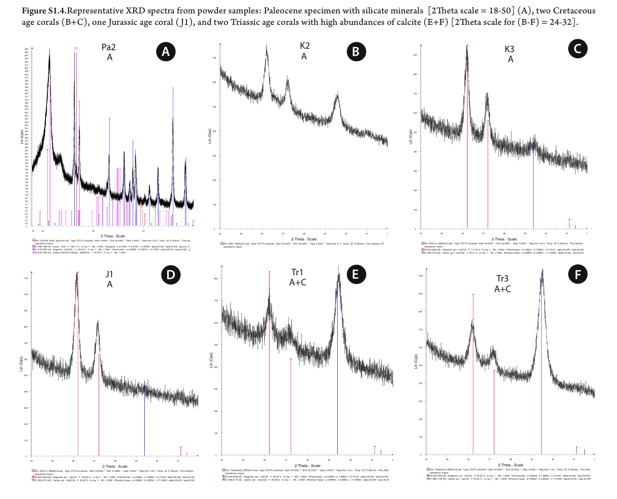

**Figure EA4d.** Representative XRD patterns for 1 Paleocene (A), 2 Cretaceous (B, D), 1 Jurassic (D), and 2 Triassic (E, F) specimens.